**Durham College**

**Artificial Intelligence Analysis, Design and Implementation**

**Capstone Term II - AIDI 2005 – 01**

**_________________________________________**

**Facial Attendance Management System**

**Group-12 Members: -**

1. **Himanshu Dhiman - 100721563**
2. **Shubham Dikshit - 100688204**
3. **Harin Shah - 100674815**
4. **Ankitkumar Patel – 100717791**

**Date: - 23- Jan- 2020**

**Business Requirements**

# Executive summary

The facial attendance system is designed to register student attendance via facial recognition technology. Manual entering of participation in logbooks turns into a difficult task and it additionally burns through the time so, we are intending to plan a productive module that contains face acknowledgment to deal with the participation records of students. With the help of this, we will be able to reduce human intervention in attendance. By utilizing this tool in schools and colleges will be able to register attendance swiftly and it will also reduce human errors.

# Problem Statement: -

So, what made us go for this project?

It was all because of the problem arising in the manual attendance system. As the utilization of ID cards swiping and physically recording names on a sheet of paper as a strategy to follow student attendance is old and time-consuming in this modern world. In the world of machines, we humans do not want to engage with manually collecting the data than manually inserting the data, requiring more time in retrieving the data, Marinating the database manually and fear of losing the data, so we are planning to build a prototype which will help school and colleges to take attendance in easy and more efficient way.

# Rationale statement: -

If we talk about the existing framework it is a manual participation framework, which is a tedious activity and it consumes a lot of time. Recovering data from this framework is additionally an exceptionally huge and tedious undertaking. In the current circumstances, either instructor must give pen and paper to students to write their name or they must call each name separately and mark the attendance. The task after this is even more time consuming, they need to transfer all data to a computer manually. This makes a simple and easy task increasingly confused and tedious. Our objective is to minimize human interference and give a progressively fissile choice for gathering participation. With facial recognition, we will have the option for humans to work less and finish the assignment of collecting attendance quicker. Moreover, recovering information will likewise be simpler than it was in the past. Repetition will likewise be wiped out with the utilization of this software.

# Key Metrics

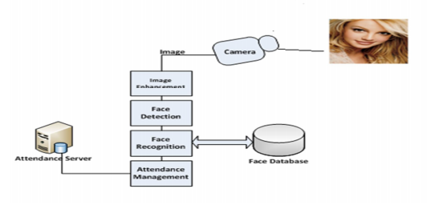

Our project is based on three main parts: Front End, Backbone(Algorithm & API) and Database.

Front End:

* This would be a website which would authorize the class facilitator to review the attendance of current class as well as review the history of every student.
* Dashboard will present the data of class and we will try to make a customize version of it, so that every facilitator can modify and view as per their own wish.
* Web interface will allow the facilitator to add and delete the student and student specific entry.
* In prototype version, we will not be providing with the authentication method.
* We will be using laptop webcam for capturing the image.

Back Bone (Algorithm):

* For the base of this project we will be using Facial Recognition library.
* This help in three processes: Detection, Identification and Recognition.
* In algorithm, will be automating the process of adding user and giving the access.
* We will be using Flask to create API for our code, which will help in building our front end.

Database:

* We will be using PostgreSQL for database.
* We receive a name as a string from a GET request of the front, make a query to the database and return the data that we get as a json.
* Database will be stored locally on the machine for the prototype.
* In future, we can take it online in order to make it more flexible to use.

API

Database

Camera with face recognition

Front End

Key Metrics Measurement:

The above define process could be measure by the below mentioned processes:

1. User Satisfaction: For this prototype, will be aiming for 85% of user satisfaction.
2. Average Response Time: Average Response time of Identification would be 30 sec.
3. Error Rates: 20 % Error rate.
4. Application Availability: 95 % of uptime.

# Refine the problem statement

Taking attendance manually is a humongous task, it consumes lots of time and it is also not feasible for a larger audience. With the help of this software, we can reduce human error and make our work easier.